COLLEGE CODE : 8222
COLLEGE NAME : UNIVERSITY COLLEGE OF ENGINEERING, THIRUKKUVALAI
DEPARTMENT : COMPUTER SCIENCE AND ENGINEERING
DATE : 03-10-2025
PROJECT-NAME : WHATNEXT VISION MOTORS

S.NO | NAME | REGISTER NO | NM-ID | PROJECT INVOLMENT
1. | LAKSHMANAN C | 822223104036 | B17AECA8533B77E882049D64C3CB41D3 | MILESTONE-1,2
2. | AKASH K | 8222230104008 | F7AA36D1F83F1059FD44CE887A9B5EAE | MILESTONE-3,4
3. | SREEJITH S T | 822223104030 | 415F2B8E03559E9BC14493474C01A919 | MILESTONE-5,6
4. | NITHISH S P | 822223104041 | F90CF77B62707869200461FD8356E17C | MILESTONE-7,8

SUBMITTED BY,
LAKSHMANAN C – TEAM LEADER AKASH K- MEMBER
SREEJITH S T- MEMBER NITHISH S P - MEMBER

WhatsNext Vision Motors: Shaping the Future of Mobility with Innovation and Excellence

Use Case

WhatsNext Vision Motors is an automotive company that wants to make buying a vehicle easier through technology and automation. To get there, it is rolling out a Salesforce-based solution that simplifies customer ordering, keeps vehicle stock under control, and cuts down on manual work.
The main goal is a smooth, customer-friendly ordering process. When a customer places an order, the system reads the customer’s address and suggests the nearest dealer automatically. Customers no longer have to hunt for a dealer themselves, and staff are spared the same effort.
The system also keeps an eye on vehicle stock while an order is being placed. If a vehicle is out of stock, the customer simply cannot order it. This prevents wrong orders, spares customers the disappointment, and keeps order processing accurate.
The project also covers bulk vehicle orders. A scheduled process regularly checks stock for the ordered vehicles and updates each order’s status. If the vehicle is available, the order becomes Confirmed. If it is not, the order stays Pending until stock arrives.
Overall, the solution is meant to improve customer satisfaction and operational efficiency. Automation takes over repetitive admin work, reduces human error, and frees employees to focus on more important tasks. Customers also get clearer order-status information and faster processing.
In short, the WhatsNext Vision Motors Salesforce project brings together customer management, dealer selection, stock validation, order processing, and automatic status updates in a single solution, giving the company a more efficient and dependable sales experience.

Requirements

The WhatsNext Vision Motors Salesforce project needs to cover the following areas to improve vehicle ordering and order management.

Customer Management
  - Users can create and manage customer records.
  - Each record holds the customer’s name, phone number, email, and address.
  - Customer details are available when a vehicle order is created.

Vehicle Management
  - Vehicle details and current stock quantity are maintained in the system.
  - Users can tell at a glance whether a vehicle is available or out of stock.
  - Stock figures can be updated whenever needed.

Dealer Management
  - The system stores each dealer’s name, location, address, and contact details.
  - It supports multiple dealers across different locations.
  - Dealer information is available while customer orders are processed.

Nearest Dealer Identification
  - When a customer creates an order, the system picks up the customer’s location from their address.
  - It then finds the nearest available dealer automatically.
  - The suggested dealer is linked to the vehicle order.
  - Customers and employees no longer have to search for a suitable dealer by hand.

Vehicle Order Creation
  - Users can create vehicle orders on behalf of customers.
  - Each order records the customer, vehicle, quantity, dealer, and order status.
  - Vehicle availability is validated before an order is processed.

Stock Availability Validation
  - Stock is checked before an order is created or confirmed.
  - If enough stock is available, the order goes ahead.
  - If the vehicle is out of stock, the customer cannot place the order.
  - A clear error message explains that the vehicle is unavailable.

Order Status Management
The order status depends on whether the vehicle is in stock.

Stock Availability | Order Status
Vehicle available | Confirmed
Vehicle unavailable | Pending

  - A Confirmed order means the vehicle is available.
  - A Pending order means the vehicle is currently unavailable and needs further processing.

Bulk Order Processing
  - The system can process multiple vehicle order records at once.
  - Bulk orders are handled without anyone updating each record by hand.
  - Stock availability is checked for every vehicle in a bulk order.

Scheduled Automation
  - A scheduled Salesforce process runs automatically at a set time.
  - It finds the vehicle orders that need a status update.
  - It checks current stock and updates each order’s status.
  - Orders for available vehicles become Confirmed.
  - Orders for unavailable vehicles stay (or become) Pending.

Automation and Error Reduction
  - Repetitive order-processing tasks are automated.
  - Manual data entry is kept to a minimum.
  - Validation rules, Apex automation, batch processing, and scheduled jobs are used where they fit.
  - Meaningful error messages appear when a requirement is not met.

Salesforce User Access
  - The right Salesforce users can create and manage customers, vehicles, dealers, and vehicle orders.
  - Each user only gets access to the records and functions their role needs.
  - Permissions are set up for the required objects and fields.

Overall Business Requirement
The finished Salesforce solution should give WhatsNext Vision Motors an automated vehicle-ordering process that follows this flow:
Customer → Select Vehicle → Check Stock → Identify Nearest Dealer → Create Order → Confirm/Pending → Automated Status Updates
This will improve customer convenience, stock accuracy, order processing, and overall operational efficiency.

Project Scope

Salesforce CRM Implementation
  - Store and manage vehicle details, stock availability, and dealer information in Salesforce.
  - Track customer orders, test drives, and service requests efficiently.
  - Automate workflows to assign orders to the nearest dealer based on the customer’s location.

Process Automation
  - Prevent order placement if the vehicle is out of stock.
  - Auto-assign orders to the nearest dealer based on the customer’s location.
  - Send automated email reminders for scheduled test drives.

Apex and Trigger
  - Implement Apex triggers to enforce business rules such as stock validation and automatic dealer assignment.
  - Use trigger handlers to follow best practices and keep the code modular and easy to maintain.

Batch Jobs
  - Develop a batch Apex job that periodically checks vehicle stock levels and updates availability.
  - Send scheduled email notifications for stock replenishment and order processing.

What You’ll Learn
- Data Modelling
- Fields and Relationships
- Lightning App Builder

- Record-Triggered Flows
- Apex and Apex Triggers
- Batch Apex
- Scheduled Apex

Milestone 1: Developer Account Setup

Activity 1: Creating a Developer Account
Create a developer org in Salesforce.
- Go to https://developer.salesforce.com/signup
- On the sign-up form, enter the following details:
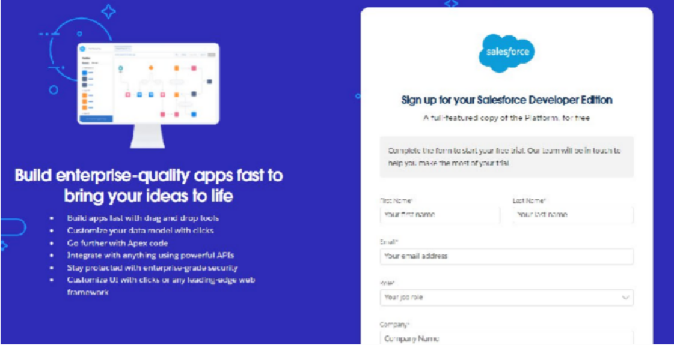
  - First name and last name
  - Email
  - Role: Developer
  - Company: College Name
  - Country: India
  - Postal code: your pin code
  - Username: a combination of your name and company
The username does not have to be a real email address. Anything in the format username@organization.com will work.
- Click Sign me up once everything is filled in.

Activity 2: Account Activation
- Open the inbox of the email address you signed up with and click Verify Account in the Salesforce email. It can take 5–10 minutes to arrive.

- Set a password, answer the security question, and click Change Password.
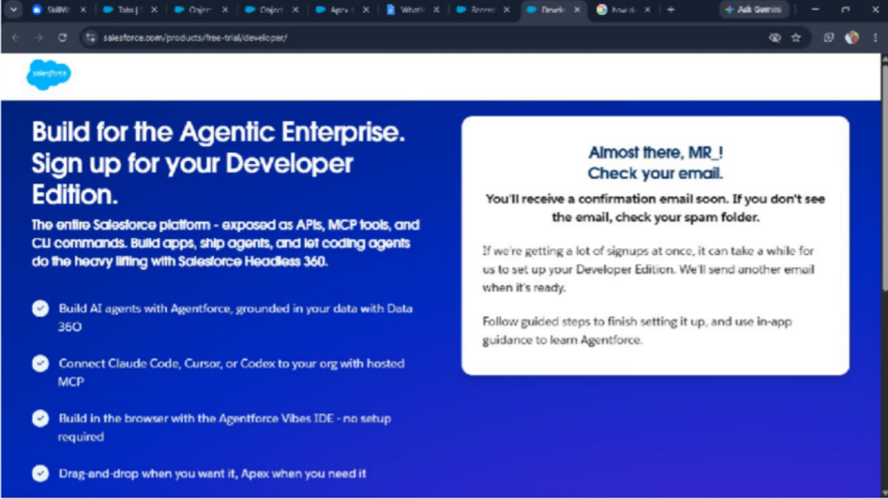
- You will then be redirected to your Salesforce Setup page.
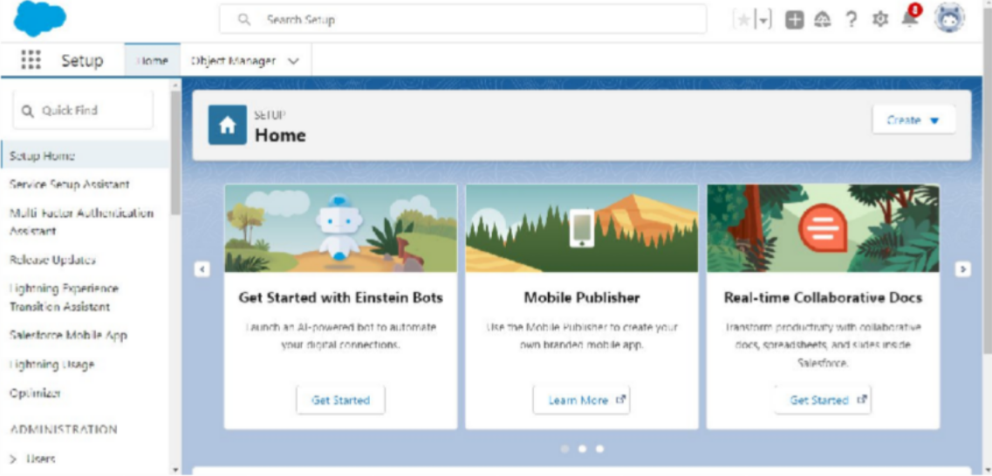

Milestone 2: Objects and Relationships

The project uses the following custom objects.

Object Name | Purpose | Relationships
Vehicle c | Stores vehicle details | Related to Dealer & Orders
Vehicle_Dealer c | Stores authorized dealer info | Related to Orders
Vehicle_Customer c | Stores customer details | Related to Orders & Test Drives
Vehicle_Order c | Tracks vehicle purchases | Related to Customer & Vehicle
Vehicle_Test_Drive c | Tracks test drive bookings | Related to Customer & Vehicle
Vehicle_Service_Request c | Tracks vehicle servicing requests | Related to Customer & Vehicle

To navigate to the Setup page: click the gear icon, then click Setup.
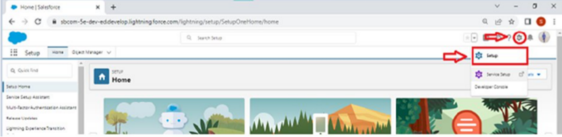

Activity 1: Create the Vehicle Object
The Vehicle custom object keeps the details of every vehicle in one place. To create the object:
- From the Setup page, click Object Manager → Create → Custom Object.
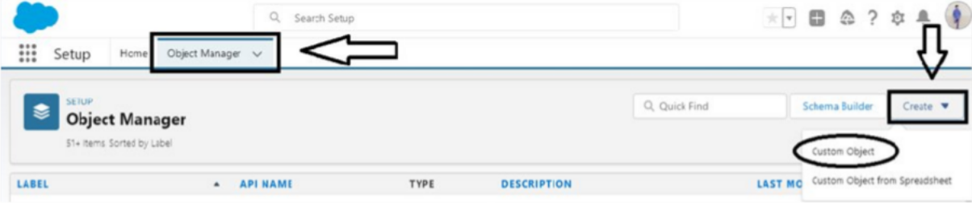
- Enter the label name: Vehicle
- Enter the plural label name: Vehicles
- Under Record Name Label and Format, set:
  - Record Name: Vehicle Name

  - Data Type: Text
- Select Allow Reports.
- Select Allow Search, then click Save.

Activity 2: Create the Dealer Object
The Dealer custom object stores detailed information about each dealer. To create the object:
- From the Setup page, click Object Manager → Create → Custom Object.
- Enter the label name: Vehicle Dealer
- Enter the plural label name: Vehicle Dealers
- Under Record Name Label and Format, set:
  - Record Name: Dealer Name
  - Data Type: Text
- Select Allow Reports.
- Select Allow Search, then click Save.
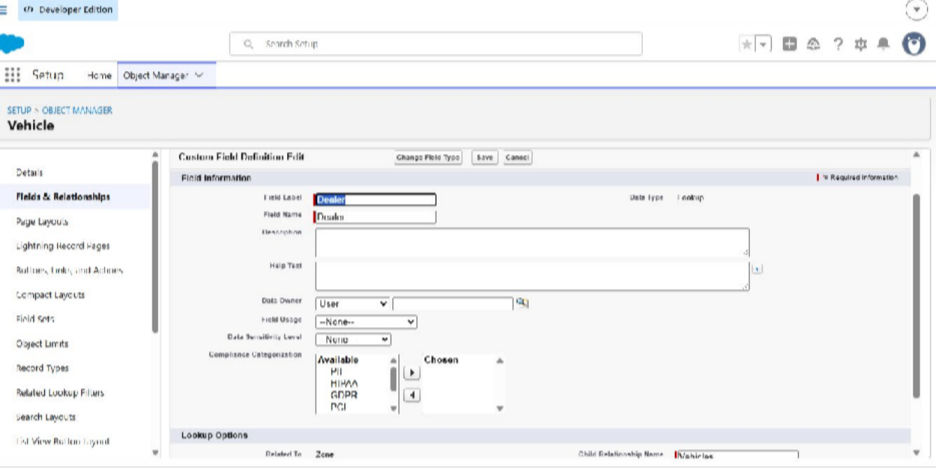

Milestone 3: Tabs

Activity 1: Creating a Custom Tab (Vehicle)
- Go to Setup, type Tabs in the Quick Find box, click Tabs, and under Custom Object Tabs click New.
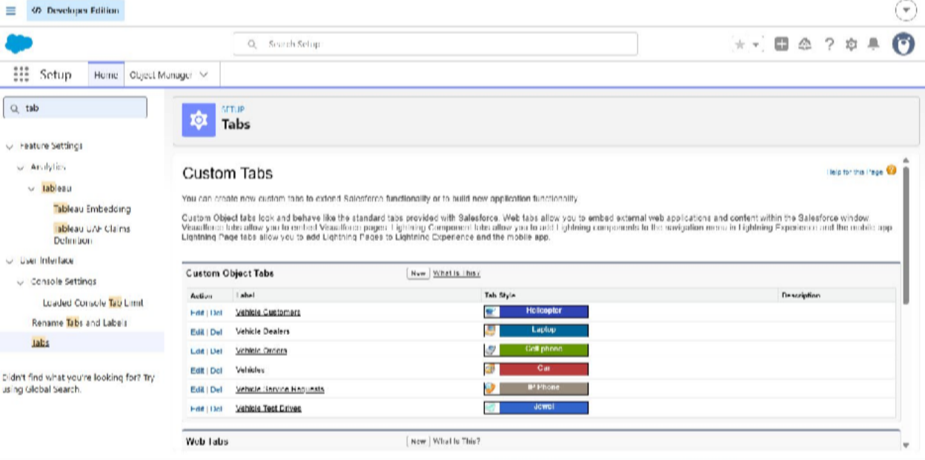
- Select the object (Vehicle) and choose any tab style, then click Next. Keep the defaults on the Add to Profiles page and click Next, keep the defaults on the Add to Custom App page, and click Save.
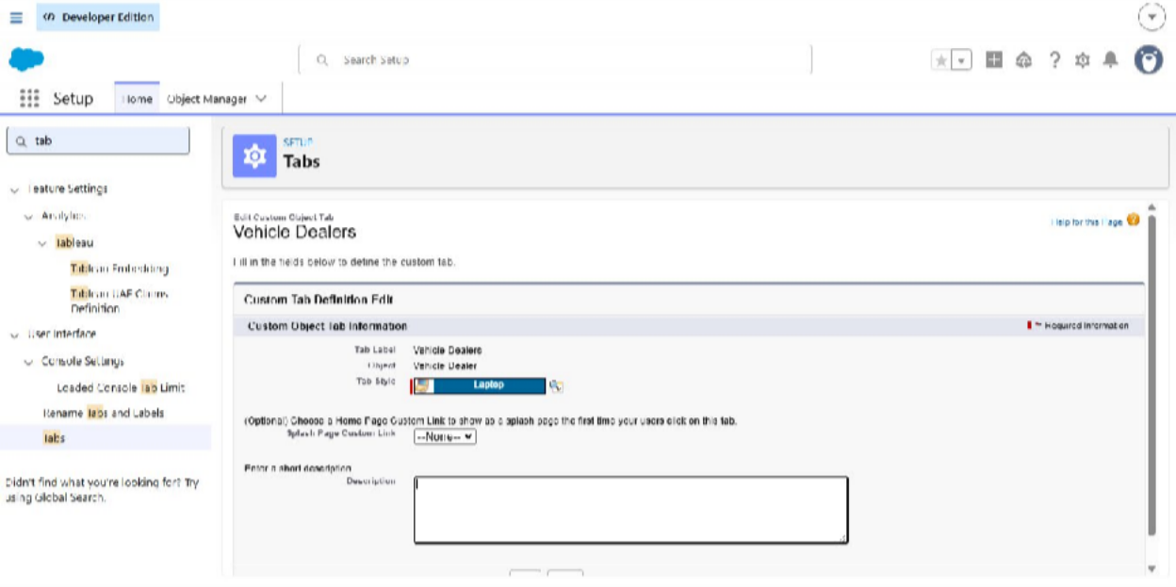

Activity 2: Creating Tabs for the Other Objects
Create tabs for the remaining objects you set up earlier in the same way.

Milestone 4: The Lightning App

Activity 1: Create a Lightning App
To create a Lightning app:
- Go to Setup, search for “App Manager” in Quick Find, select App Manager, and click New Lightning App.
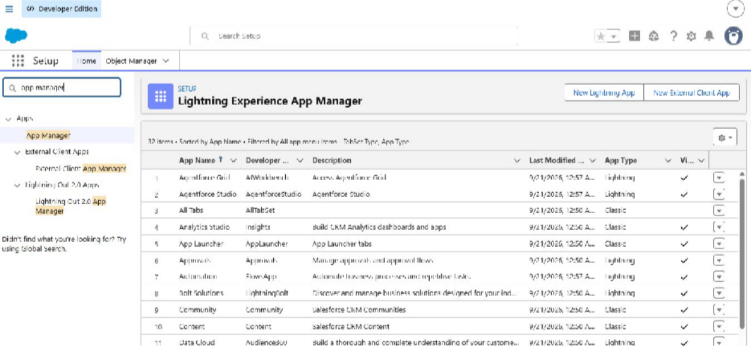
- Fill in the app details and branding as follows: App Name: WhatsNext Vision Motors Developer Name: populated automatically Description: add a short, meaningful description Image: optional
Primary Color Hex Value: keep the default

- Click Next. Keep the defaults on the App Options page and click Next, then keep the defaults on the Utility Items page and click Next.
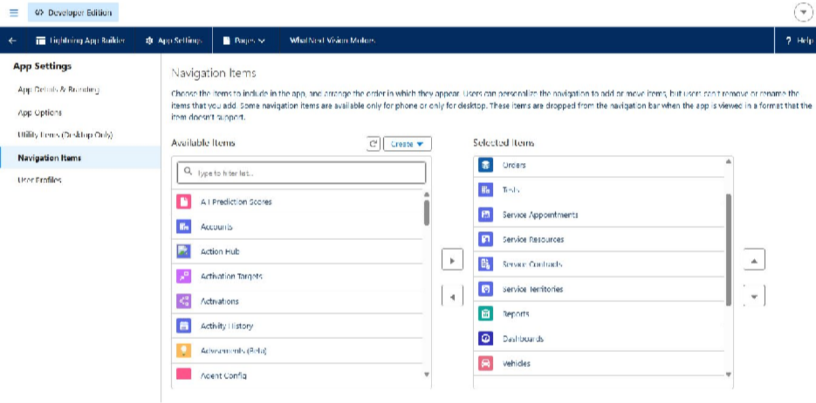
- To add navigation items, search for Vehicle, Dealer, Customer, Order, Test Drive, Service Request, Reports, and Dashboard, and move each one across with the arrow button. Then click Next.
Note: choose the custom objects you created in the earlier activities.
- To add user profiles, search for the System Administrator profile, move it across with the arrow button, and click Save & Finish.
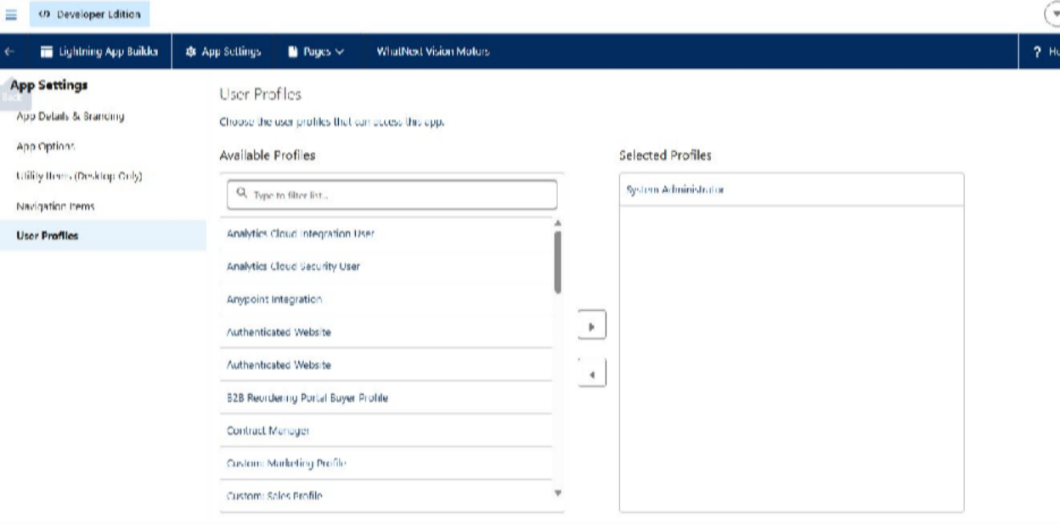

Milestone 5: Fields and Relationships

Key Fields for Each Object

Vehicle c (Custom Object)
  - Vehicle Name (Text)
  - Vehicle_Model c (Picklist: Sedan, SUV, EV, etc.)
  - Stock_Quantity c (Number)
  - Price c (Currency)
  - Dealer c (Lookup to Vehicle_Dealer c)
  - Status c (Picklist: Available, Out of Stock, Discontinued)

- Vehicle_Dealer c (Custom Object)
  - Dealer_Name c (Text)
  - Dealer_Location c (Text)
  - Dealer_Code c (Auto Number)
  - Phone c (Phone)
  - Email c (Email)

- Vehicle_Order c (Custom Object)
  - Vehicle_Customer c (Lookup to Vehicle_Customer c)
  - Vehicle c (Lookup to Vehicle c)
  - Order_Date c (Date)
  - Status c (Picklist: Pending, Confirmed, Delivered, Canceled)

- Vehicle_Customer c (Custom Object)
  - Customer_Name c (Text)
  - Email c (Email)
  - Phone c (Phone)
  - Address c (Text)
  - Preferred_Vehicle_Type c (Picklist: Sedan, SUV, EV, etc.)

- Vehicle_Test_Drive c (Custom Object)
  - Vehicle_Customer c (Lookup to Vehicle_Customer c)
  - Vehicle c (Lookup to Vehicle c)
  - Test_Drive_Date c (Date)

  - Status c (Picklist: Scheduled, Completed, Canceled)

- Vehicle_Service_Request c (Custom Object)
  - Vehicle_Customer c (Lookup to Vehicle_Customer c)
  - Vehicle c (Lookup to Vehicle c)
  - Service_Date c (Date)
  - Issue_Description c (Text)
  - Status c (Picklist: Requested, In Progress, Completed)

Activity 1: Creating a Field in the Vehicle Object
- Go to Setup, click Object Manager, type the object name (Vehicle) in the Quick Find box, and open the object.
- Click Fields & Relationships, then click New.
- Select the data type Picklist.
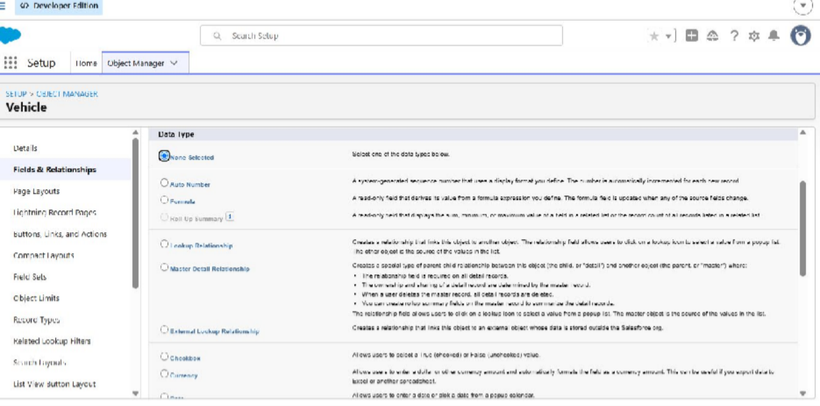

- Click Next.
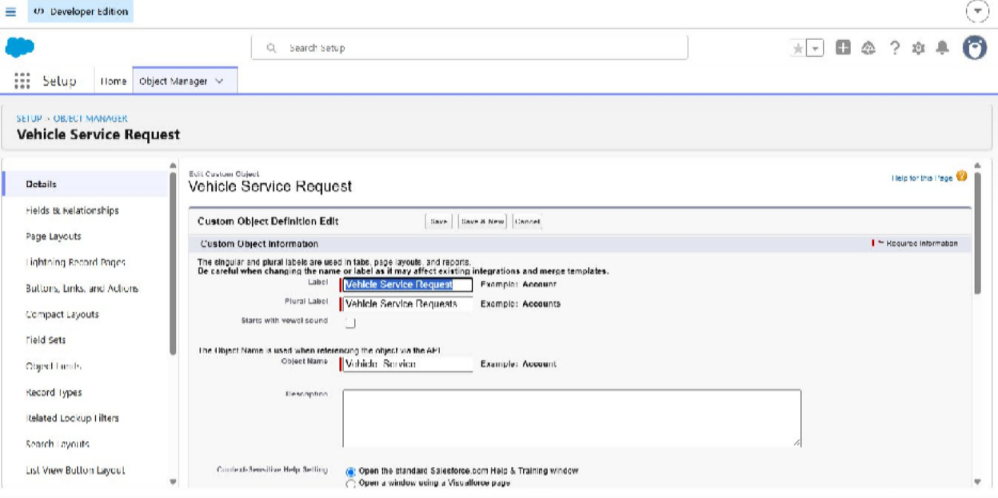
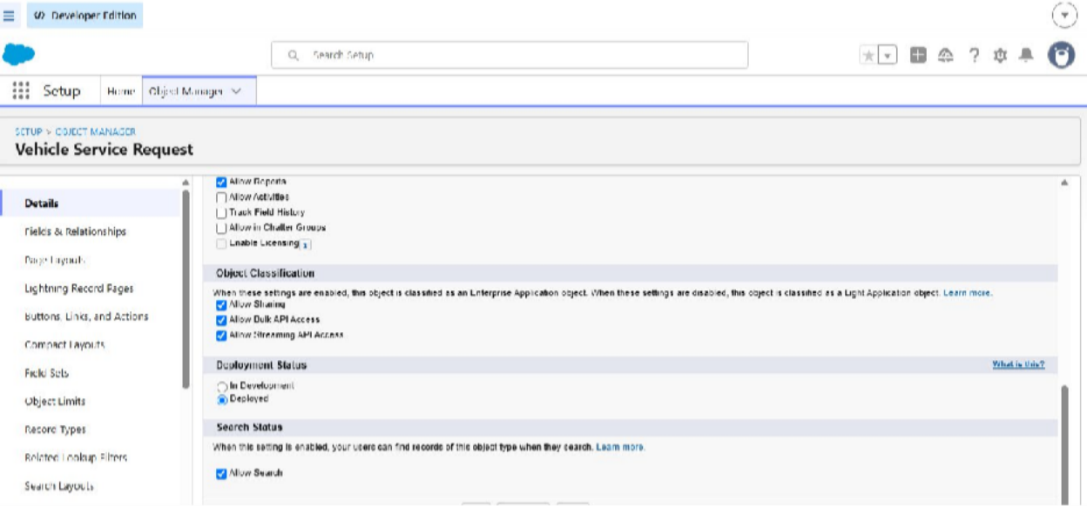

- Fill in the details as follows:
  - Field Label: Vehicle Model
  - Picklist Values: enter the values (for example Sedan, SUV, EV)
  - Click Next → Next → Save & New

Milestone 6: Flows

Flow 1: Creating a record-triggered flow to assign the nearest dealer based on the customer’s location
Step 1: In Quick Find, type Flows and click Flows. Click New Flow. Step 2: Select Triggered Automation from the flow options.
Step 3: Select Record-Triggered Flow.
Step 4: Select the Vehicle Order object.
Trigger the flow when: a record is created.
Set Entry Condition: All Conditions Are Met (AND) Field: Status c
Operator: Equals Value: Pending
Step 5: Click + and select Get Records.
Step 6: Label it Get Customer Information.
Object: Vehicle Customer Condition:
Field: Id Operator: Equals
Value: {!$Record.Vehicle_Customer c}
Step 7: Click + and select Get Records again. Label it Get Nearest Dealer.
Object: Vehicle Dealer Condition:
Field: Dealer_Location c Operator: Equals
Value: {!Get_Customer_Information.Address c}
Step 8: Click + and select Update Records. Label it Assign Dealer to Order.
How to Find Records to Update and Set Their Values: use the IDs and all field values from a record or record collection.
Select Record(s) to Update: {!Get_Nearest_Dealer}

Step 9: Click Save and give the flow a label.
Label Name: Auto Assign Dealer
Step 10: Activate the flow.
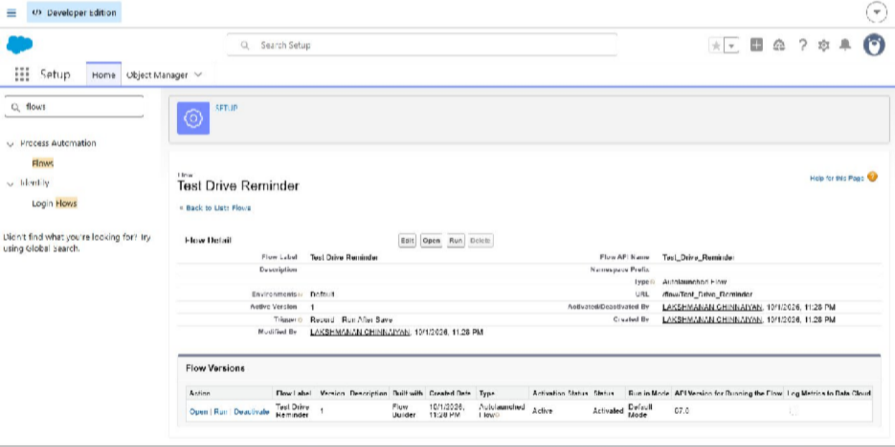

Flow 2: Creating a record-triggered flow to email the customer a test drive reminder
Step 1: Select Record-Triggered Flow. Step 2: Select the Vehicle Test Drive object.
Trigger the flow when: a record is created or updated.
Set Entry Condition: All Conditions Are Met (AND) Field: Status c
Operator: Equals Value: Scheduled
Step 3: Click + Add Scheduled Paths below the trigger.
Label: Reminder Before Test Drive Time Source: Test_Drive_Date c Offset Number: 1
Offset Options: Days Before Click Done.

Step 4: Get the customer’s details.
- Click + Add Element → Get Records.
- Label: Get Customer Information
- Object: Vehicle_Customer c
- Filter Conditions: Id = {!$Record.Vehicle_Customer c}
- How Many Records to Store: Only the first record
- How to Store Record Data: Automatically store all fields
Step 5: Send the reminder email.
- Click + Add Element → Action.
- Action Type: Send Email
- Label: Send Test Drive Reminder
- Subject: “Reminder: Your Test Drive is Tomorrow!”
- Recipient Address List: {!Get_Customer_Information.Email c}
- Rich-Text-Formatted Body: True
- Body: Create a variable
- API Name: EmailSent
Step 6: Click Save.
Label Name: Test Drive Reminder
Step 7: Activate the flow.

Flow page after creation:
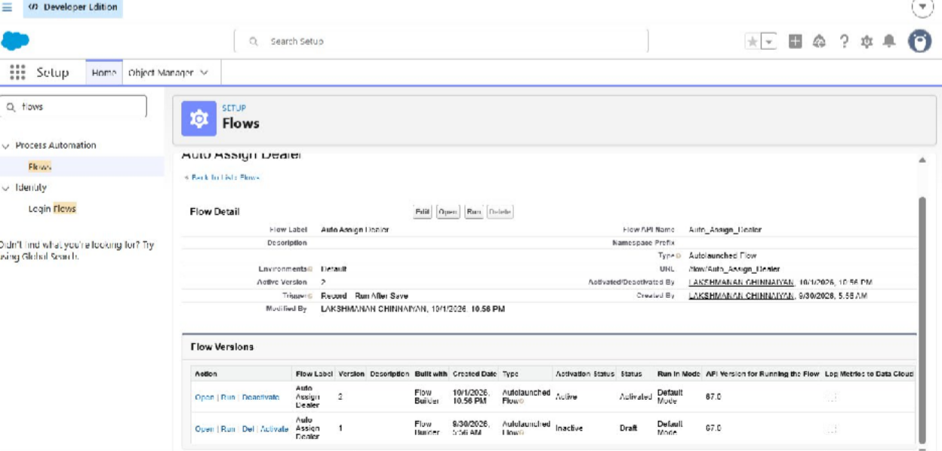

Milestone 7: Apex, Triggers and Batch Jobs

Creating the Apex Trigger and Batch Jobs
Step 1: Open the Developer Console from the gear icon.
Step 2: Click File → New → Apex Class.
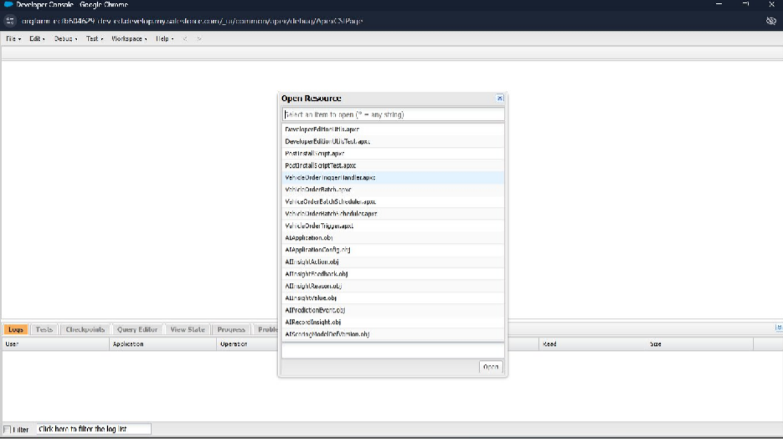
Step 3: Name the Apex class VehicleOrderTriggerHandler. Step 4: Write the Apex code.

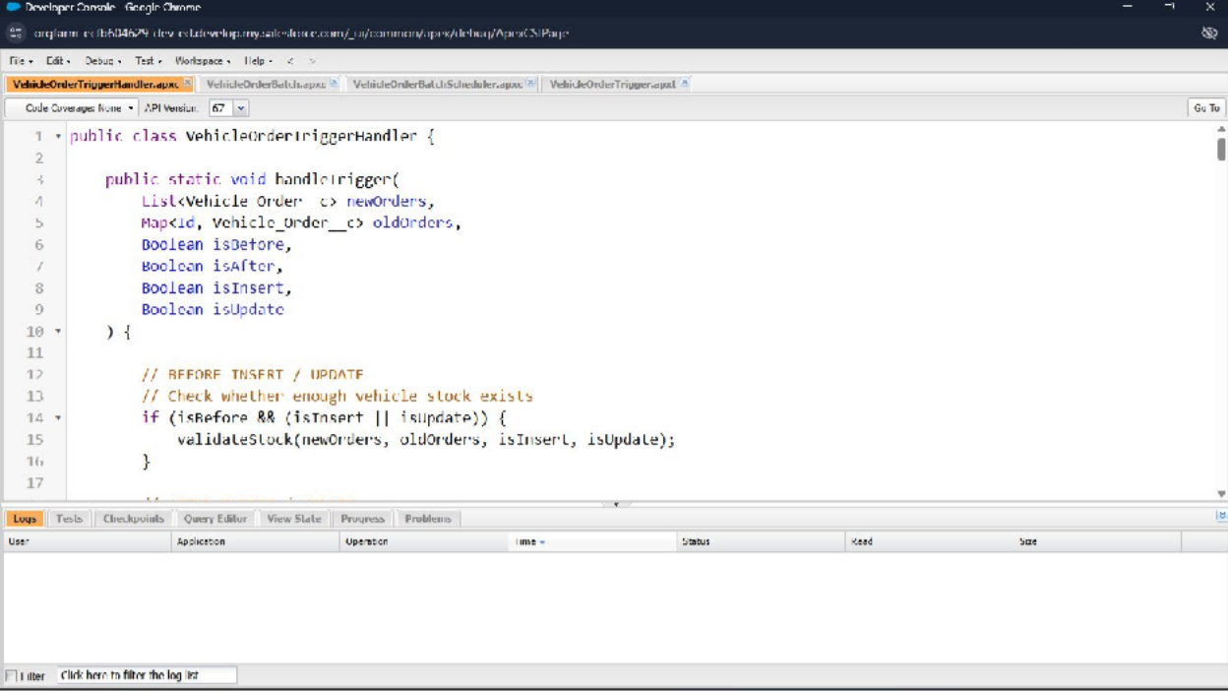

Source code:
public class VehicleOrderTriggerHandler {
public static void handleTrigger(List<Vehicle_Order c> newOrders, Map<Id, Vehicle_Order c> oldOrders, Boolean isBefore, Boolean isAfter,
Boolean isInsert, Boolean isUpdate) { if (isBefore) {
if (isInsert || isUpdate) { preventOrderIfOutOfStock(newOrders);
}
}

if (isAfter) {
if (isInsert || isUpdate) { updateStockOnOrderPlacement(newOrders);
}
}
}

// Method to prevent orders when the vehicle is out of stock
private static void preventOrderIfOutOfStock(List<Vehicle_Order c> orders) { Set<Id> vehicleIds = new Set<Id>();
for (Vehicle_Order c order : orders) { if (order.Vehicle c != null) {
vehicleIds.add(order.Vehicle c);
}
}

if (!vehicleIds.isEmpty()) {
Map<Id, Vehicle c> vehicleStockMap = new Map<Id, Vehicle c>(); for (Vehicle c vehicle : [SELECT Id, Stock_Quantity c
FROM Vehicle c WHERE Id IN :vehicleIds]) { vehicleStockMap.put(vehicle.Id, vehicle);
}

for (Vehicle_Order c order : orders) {
if (vehicleStockMap.containsKey(order.Vehicle c)) {

Vehicle c vehicle = vehicleStockMap.get(order.Vehicle c); if (vehicle.Stock_Quantity c <= 0) {
order.addError(
'This vehicle is out of stock. Order cannot be placed.');
}
}
}
}
}

// Method to update vehicle stock when an order is placed
private static void updateStockOnOrderPlacement(List<Vehicle_Order c> orders) { Set<Id> vehicleIds = new Set<Id>();
for (Vehicle_Order c order : orders) {
if (order.Vehicle c != null && order.Status c == 'Confirmed') { vehicleIds.add(order.Vehicle c);
}
}

if (!vehicleIds.isEmpty()) {
Map<Id, Vehicle c> vehicleStockMap = new Map<Id, Vehicle c>(); for (Vehicle c vehicle : [SELECT Id, Stock_Quantity c
FROM Vehicle c WHERE Id IN :vehicleIds]) { vehicleStockMap.put(vehicle.Id, vehicle);
}

List<Vehicle c> vehiclesToUpdate = new List<Vehicle c>(); for (Vehicle_Order c order : orders) {
if (vehicleStockMap.containsKey(order.Vehicle c)) {
Vehicle c vehicle = vehicleStockMap.get(order.Vehicle c); if (vehicle.Stock_Quantity c > 0) {
vehicle.Stock_Quantity c -= 1; vehiclesToUpdate.add(vehicle);
}
}
}

if (!vehiclesToUpdate.isEmpty()) { update vehiclesToUpdate;
}
}
}
}

Step 5: Create the Apex trigger (File → New → Apex Trigger).
Step 6: Enter a name for the trigger and select the Vehicle Order object (Vehicle_Order c).
Step 7: Call the Apex class from the trigger.
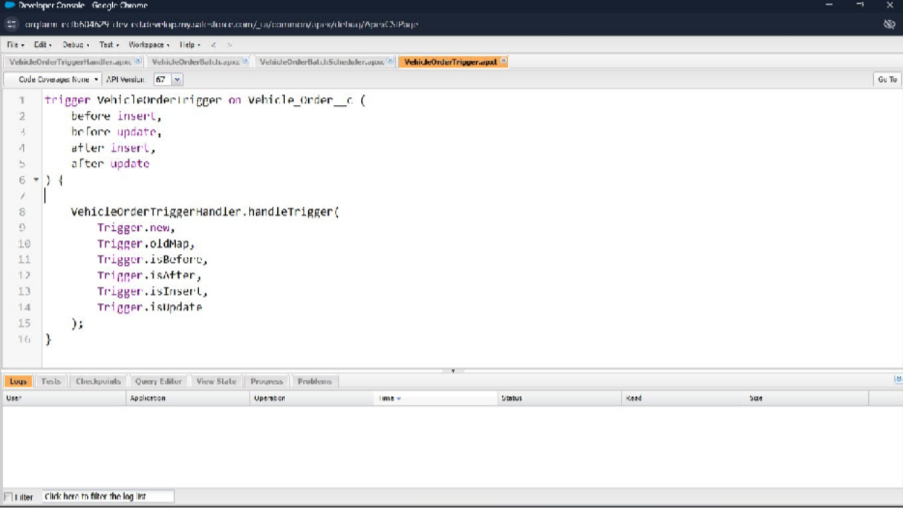
Step 8: Create the batch job.
Scenario: a customer places an order, but the vehicle is out of stock.
- The order stays Pending.
- Once new stock is added, the batch job updates the order to Confirmed.

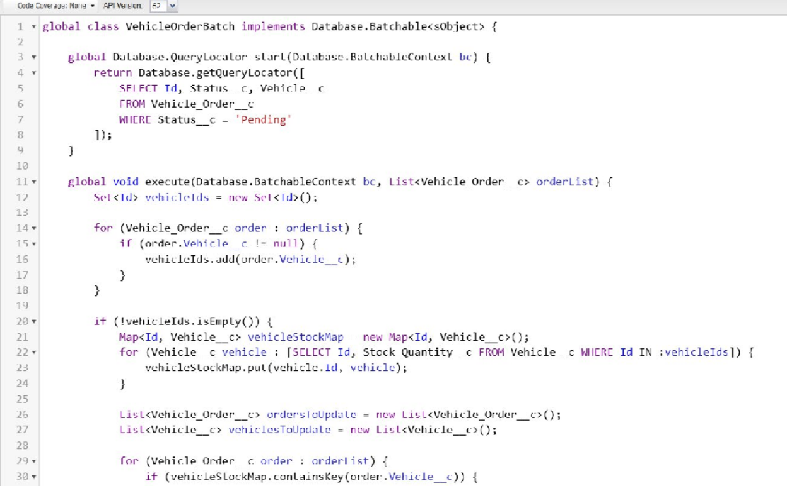

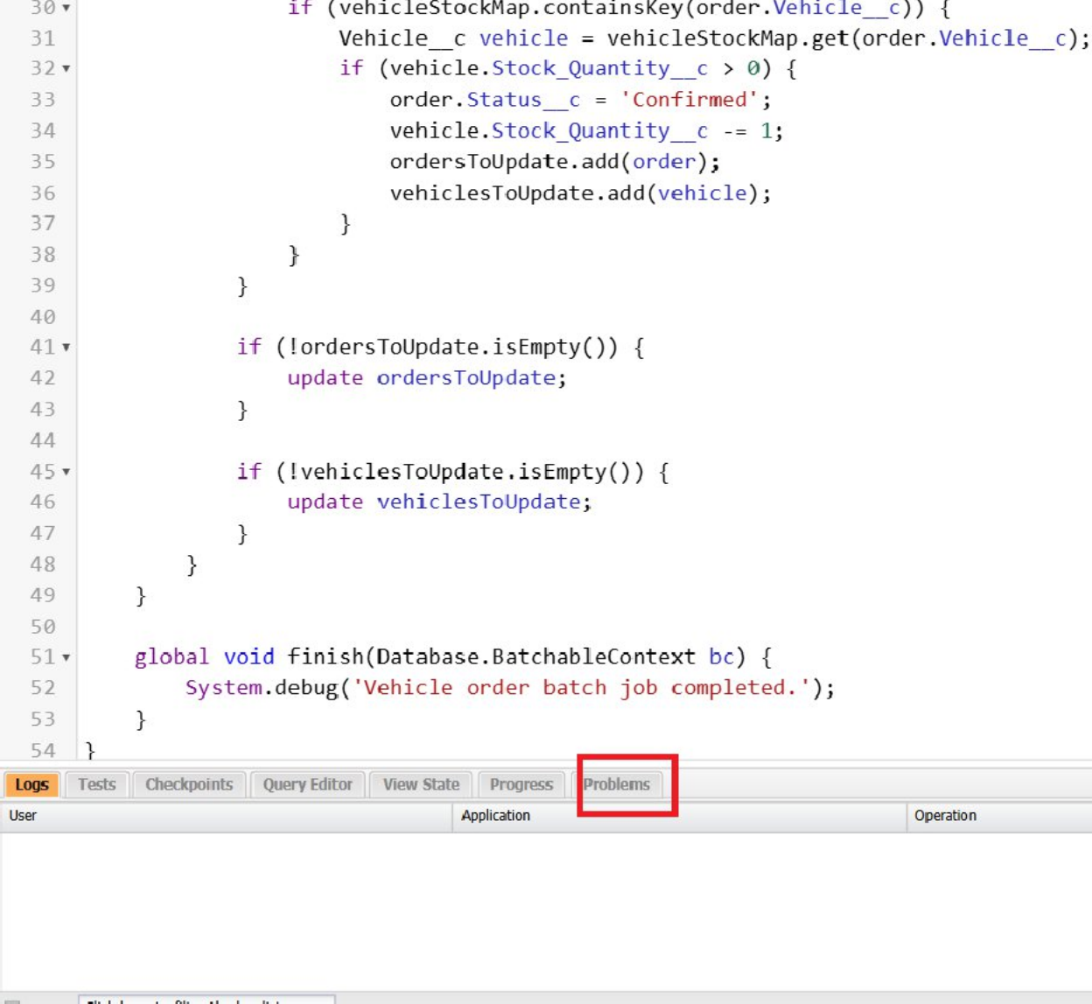
Step 9: Create a schedule class that calls the batch class.
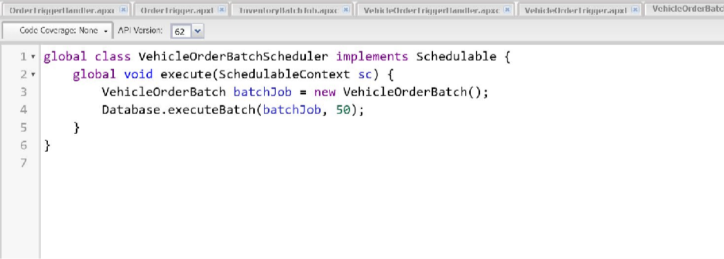

Source code:
global class VehicleOrderBatchScheduler implements Schedulable { global void execute(SchedulableContext sc) {
VehicleOrderBatch batchJob = new VehicleOrderBatch(); Database.executeBatch(batchJob, 50); // 50 is the batch size
}
}

Step 10: Schedule the batch job to run daily at 12:00 PM (noon).
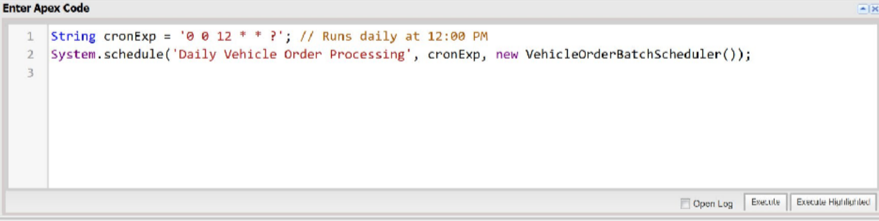

Source code:
String cronExp = '0 0 12 * * ?'; // Runs daily at 12:00 PM System.schedule('Daily Vehicle Order Processing', cronExp,
new VehicleOrderBatchScheduler());

Step 11: Check that the scheduled job is running.
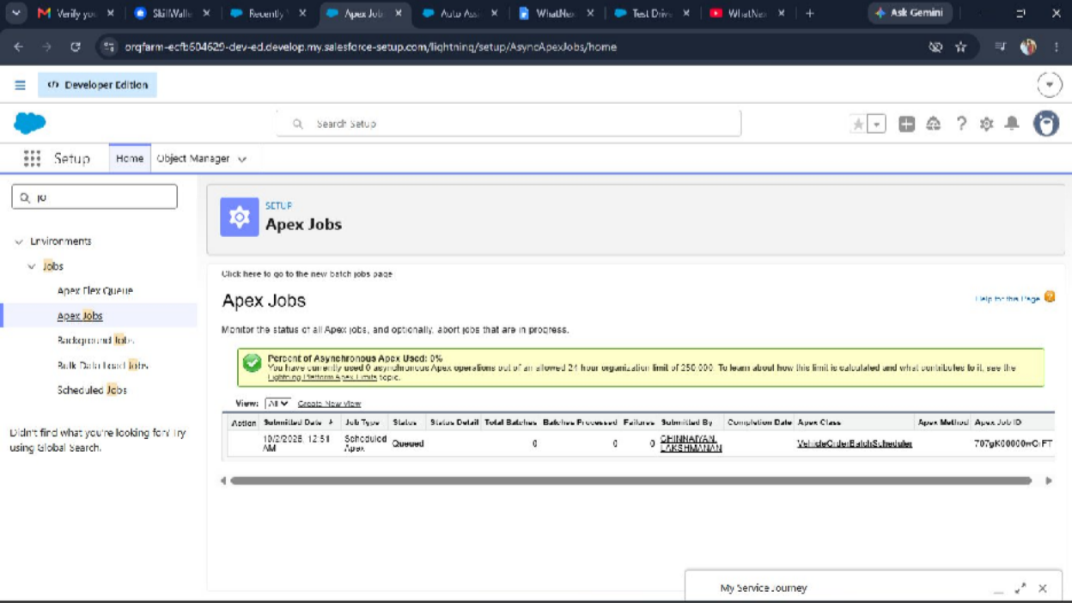

Thank you

